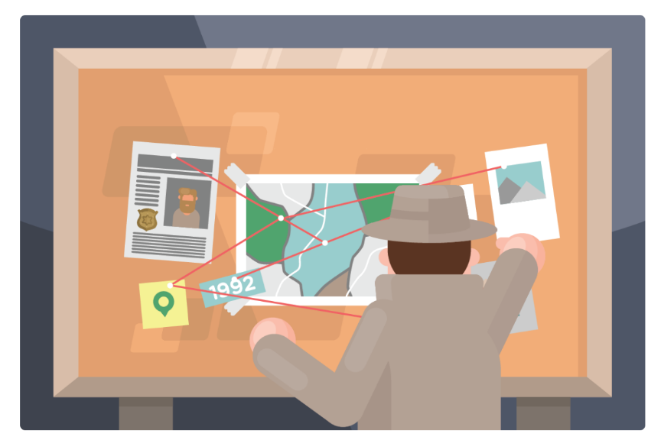
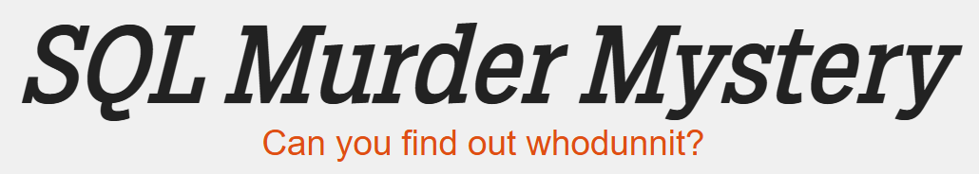

Websites We Will Use
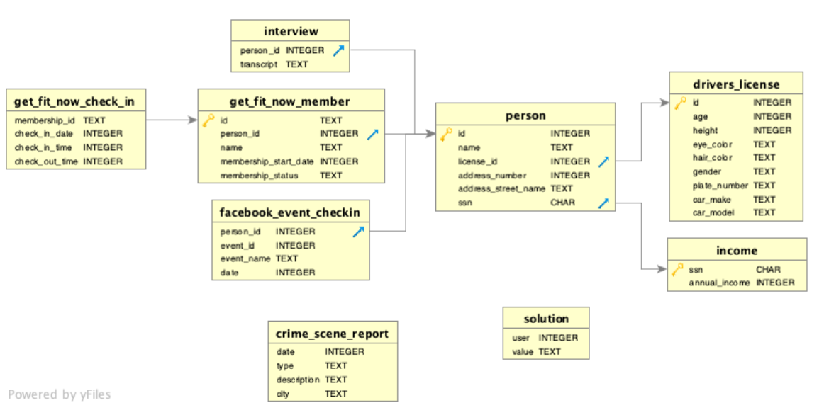
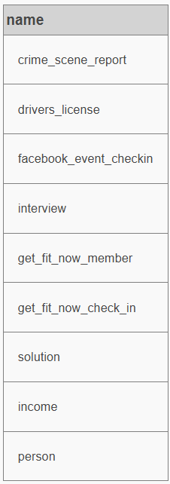
- https://mystery.knightlab.com/walkthrough.html
- https://github.com/NUKnightLab/sql-mysteries

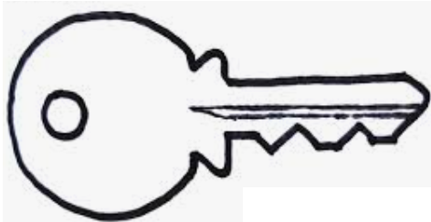
- gold key icons – the column is the primary key of the corresponding table

- blue arrow icons – the column is the foreign key of the corresponding table
- gray arrows – connect matching columns (common identifiers) from two tables
Primary Key​: a unique identifier for each row in a table
Foreign Key​: used to reference data in one table to those in another table

Commands (the blue font words)
Capital Letters | Lower Case Letters
SELECT (choose) | count
FROM (name of table) | max
LIMIT (list only first __ rows) | min
DISTINCT (remove repeats) | sum
WHERE | avg
AND
LIKE
BETWEEN
ORDER BY
ASC (ascending – lowest to highest)
DESC (descending – highest to lowest)
JOIN (two tables)
ON (which other table to join)

"Human SQL" (High Energy & Movement)
This mimics the SELECT and WHERE clauses using the students themselves as the data.
- The Game: Have the whole class stand up. You act as the "Query Runner."
- The Clauses: * Say: "SELECT * FROM Class WHERE shoes = 'White'" (All students with white shoes stay standing; others sit).
  - Say: "AND hair_length = 'Short'" (Of those standing, only those with short hair stay up).
  - Say: "ORDER BY height DESC" (The remaining students line up from tallest to shortest).
- The Bridge: Tell them they are about to do this same thing to find a killer in a city of thousands of people.

List
- 24 one-sided printout of document
- Page protectors
- Project spider-web of tables onto screen
- Warmup
- On all computers: https://mystery.knightlab.com/walkthrough.html

